On The Grounds…..

[](http://bounceaboutct.com/)



[](http://www.roamingrailroad.com/)

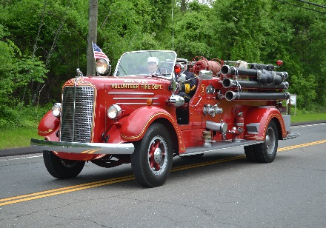



Avon’s Fire Trucks

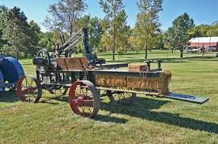

Avon’s Own Vintage Hay Bailer

Have Nose Will Travel Clowns

[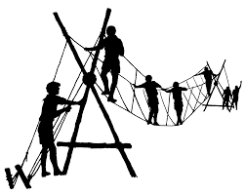](https://www.google.com/imgres?imgurl=http://www.boyscouttroop208.org/monkeybridge2.gif&imgrefurl=http://www.boyscouttroop208.org/join_scouts.html&docid=Qj4qYyLhr7XkCM&tbnid=FZciI_hAJrroTM:&vet=10ahUKEwj1i6jCrsXTAhUE44MKHTrGCKk4yAEQMwgNKAswCw..i&w=1810&h=1443&bih=841&biw=1745&q=boy%20scout%20bridge&ved=0ahUKEwj1i6jCrsXTAhUE44MKHTrGCKk4yAEQMwgNKAswCw&iact=mrc&uact=8)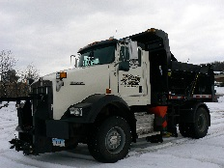

Boy Scout Bridge

Public Works

Touch-a-Truck