POCD CHAPTER 5 (DRAFT) Open Space and Recreation August 17, 2016

Preservation of adequate amounts of open space helps to retain a positive connection with Avon’s more rural past, helps establish community character, and permits residents to maintain a relationship with the natural environment. The preservation of open space also directly contributes to public safety and environmental protection by preserving assets that mitigate damage from flooding and have the ability to filter pollutants dissolved or suspended in stormwater runoff.

In addition, the Town must maintain areas for active recreation, which match demand for the use of these facilities as the population grows and as demand for participation in organized athletic activities also continues to grow.

The preservation of open space also results in positive fiscal impacts. It is well accepted that the cost of acquiring open space even at fair market value, plus the cost associated with yearly maintenance, is substantially less than the costs associated with the private development of the same asset. A partial list of the resulting costs associated with private development include school construction and general education, road maintenance, utility maintenance, police and fire protection, etc.

Avon is fortunate to have a stunning, natural landscape which includes 3 prominent ridgelines known as Avon Mountain, Pond Ledge, and Huckleberry Hill; more than 7 miles of the Farmington River; broad expanses of floodplain; farmland; and large, unfragmented areas of upland woodland.

There are sizeable areas of protected open space that are owned by the Town, the Avon Land Trust, the State, private associations, and private interests. Map 5-1 depicts existing open space parcels by ownership.

There are 146 parcels categorized as open space which total 2,859 acres or 19.7% of the Town. This is summarized in Table 5-1.

OWNERSHIP | # OF PARCELS | # of ACRES
Town | 70 | 1,124
State | 14 | 421
Private | 18 | 705
Private Recreation | 9 | 454
Utility | 4 | 113
Avon Land Trust | 34 | 296
Avon Land Trust Easements | 2 | 35
TOTAL | 151 | 3,148
Table 5-1 Summary of Existing Open Space Assets.

Residents of Avon clearly understand the benefits of open space preservation. The community survey conducted by the Commission during the preparation of this Plan (see Appendix A) highlighted residents’ interest in preserving open space. The preservation of open space by purchasing undeveloped land is more important to residents (88%) than commercial development (51.2%) or industrial development (32.9%). Most residents would support somewhat higher taxes to preserve additional valuable open space assets. By a large majority 74.3% of residents would accept an annual tax increase of $50 for up to 10 years. A slightly smaller but still impressive group, 71.6%, would accept a $100 increase.

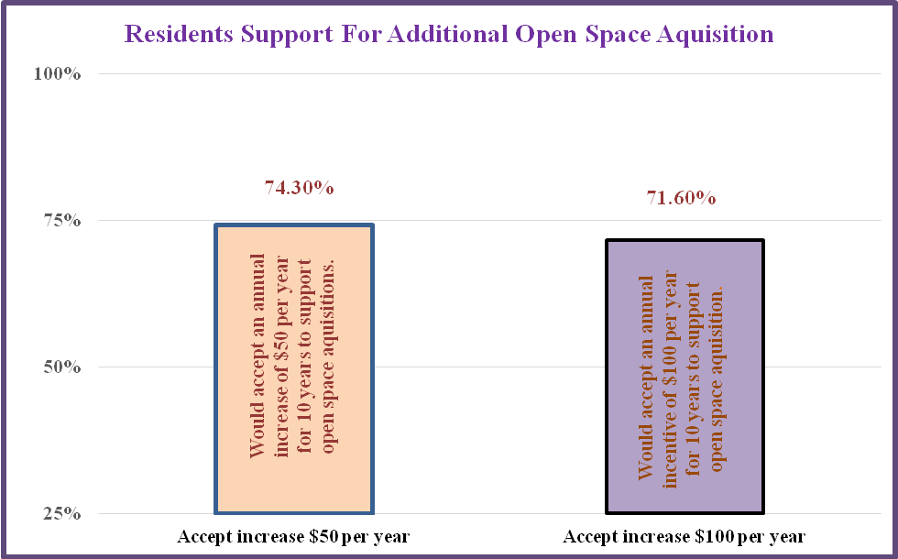
Table 5-2 Residents’ Support for Additional Open Space Acquisition

Although public consensus is clear, it is important to note that the Planning and Zoning Commission must act in accordance with State law. Regulations cannot simply be adopted denying private land owners the ability to make reasonable use of their land. The word “reasonable” has been defined by decades of cases heard by Connecticut courts. It is clear that the Commission cannot simply create an open space zone as a means to preserve undeveloped land. Such an approach would be considered “confiscatory” and a “taking without just compensation” under State law.

Towns may require the transfer to the Town of modest amounts of open space when approving subdivision applications. In 2006, this Plan recommended increasing this requirement from 5% to 10%. This change was adopted in 2006.

Encouraging a design concept known as cluster zoning or open space zoning may result in a subdivision which yields roughly the same number of homes on smaller lots making it possible to preserve larger areas of open space. The Commission encourages the use of cluster subdivisions where public sewer and water is available or in instances where soil conditions are suitable for individual or community onsite subsurface sewage disposal systems, and where adequate buffers may be created adjacent to established housing. Chapter 7 discusses possible regulatory changes which would make cluster development a more attractive option for private real estate developers, as compared to conventional large lot subdivisions.

State law also permits the Planning and Zoning Commission to accept a “fee in lieu of open space”. Regulations were adopted in 2000 authorizing a payment of 5% of the pre-approved value of the land to be subdivided in lieu of the dedication of open space. This requirement was increased to 10% in 2004. Under State law an applicant must first elect this option and then the Commission must agree that such payment is preferred over the actual dedication of land. This fee-in-lieu option has been used frequently by the Commission in instances where a proposed subdivision is not adjacent to other Town open space assets, does not include land set as a priority for preservation under this Plan, or where the obligation is small resulting in the possible dedication of a very small parcel of land. Funds from the fee-in-lieu program are placed in a separate Town account and can only be used to purchase open space elsewhere in Avon or make capital improvements to existing open space assets. Since 2000 the fee-in-lieu open space fund has grown to $600,000 and as of 2016, no dollars have been spent from this account. If possible, these funds should be used as matching dollars to State and Federal grant programs as a means to acquire more significant properties.

In addition to open space dedication and fee-in-lieu, the Commission may wish to consider changes which would permit applicants the ability to satisfy open space obligations through the use of conservation easements in select instances. In comparison to fee dedication and fee-in-lieu, this would be the least preferred option and should be used only when these other options are not possible.

Since the adoption of Subdivision Regulations in 1957, the Town has acquired many parcels of open space that have contributed substantially to the overall open space network. Table 5-3 presents a list of five open space properties acquired from 2006 to 2014, which in total comprise 56.5 acres.

SUBDIVISION | ACRES PRESERVED | YEAR
Knoll Lane | 3 | 2006
Rivendell | 17 | 2010
140 Huckleberry Hill | .5 | 2012
Weatherstone | 22 | 2013
Stratford Crossing | 13 | 2014
TOTAL | 56.5
Table 5-3 Open Space acquired through subdivision review 2006-2014

In several instances the Commission has determined that the ownership and custody of open space can be best managed by the Avon Land Trust. In these instances the Commission has required that developers satisfy their open space obligations by deeding land to the land trust. This partnership has served the interests of the community well and should be continued. The Avon Land Trust has also acquired many parcels of open space through the generous donations of individuals. The Land Trust now owns 24 parcels totaling 313 acres. The preservation of open space can be accomplished in several ways, as outlined below in Table 5-4.

MEANS TO PRESERVE OPEN SPACE | EXAMPLES
Dedication to Town as a requirement of development approval by the Planning and Zoning Commission | 22 acres – Huckleberry Hill/Weatherstone Subdivision (2013)  150 acres located to rear (east) of Hunters Run Condominiums
Purchased by Town at fair market value often with financial assistance from State and/or Federal government | Fisher Meadows  Fisher Farm 317 acres  Huckleberry Hill Open Space 250 acres
Donation to Town or Avon Land Trust by private individuals | Foster property 441 Waterville Road 3.3 acres
Dedication to private homeowners association as a result of approvals by the Planning and Zoning Commission | 13 acres – Stratford Crossing Subdivision (2014)
Held in private ownership but subject to a conservation easement in favor of the Town or Avon Land Trust as required by the Planning and Zoning Commission as part of an application approval process | Substantial wetland located to the rear of Avon Marketplace, 380 West Main Street
Table 5-4 Principal means to protect open space.

It is important to note that land commonly referred to as open space, in fact, has different levels of protection with regard to the certainty that the land will always remain open and undeveloped. In fact, although it is a goal of this Plan to permanently protect all existing open space assets identified in this Plan, those guarantees cannot necessarily be made in perpetuity. It is likely that these assets will remain undeveloped but that cannot always be assured. Important variables include whether the property contains restrictions in the deed, whether the property is in private or public ownership, and physical and regulatory constraints such as zoning, floodplain, wetlands, and steep slopes. The degree of certainty regarding permanent protection can, perhaps, be best thought of in a continuum from most to least protected. Table 5-5 provides examples of open space parcels, how they were acquired, deed restrictions, and regulatory constraints, in an effort to further highlight this concept.

All parcels owned by Avon Land Trust are deed restricted prohibiting development (except for 1)  Less Protected More Protected  ←--------------------_______________ | In very rare instances, even restrictions can be removed. (i.e., In 2010 the Avon Land Trust was successful in removing restrictions on a 1 acre parcel located off Haynes Road in order to trade it for a 17-acre parcel of valuable open space located south of Chidsey Road.
150-acre Found Land  Huckleberry Hill | Town gained ownership in 1960s by special act of State legislature and although there are no plans to do so, a bill could, theoretically, be introduced to amend legislation.
Fisher Meadows Recreation Area  208 acres | Purchased in part with funding from the National Park Service. No development is allowed unless the Town were to acquire land of equal value which would then be subject to similar restriction.
Huckleberry Hill Open Space  236 acres | Purchased in 1967 using only Town funds. No state or federal grants. Highly unlikely would ever be used for development but not restricted.
Blue Fox Run Golf Course  155 acres | Property is in private ownership and not deed restricted; however land is located within a highly regulated flood-prone area making development unlikely.
Avon Country Club  116 acres | Private real estate that is owned by members of the Club, currently in an ROS zone. Recently the Club voted to sell a 6-acre parcel for development into a 5-lot subdivision (Eagle View Estates), located off Pioneer Drive.
Table 5-5 Examples of existing open space and how they are “protected”.

It should be noted that as shown in Table 5-1, the 70 parcels of open space under Town ownership represent more than 50% of all open space. Notwithstanding the preceding discussion, any plan to use these properties (or any portion) for development is ultimately in the control of the Avon Town Council. These matters would be discussed in public session with opportunities for public participation. In addition, any proposed sale of Town-owned land requires a public hearing in accordance with the Town Charter and under Section 8-24 of the Connecticut General Statutes a referral to the Planning and Zoning Commission, who must review the proposal and determine if it is consistent with this Plan.

Open Space Priorities
Map 5-2 presents a mapped view of existing open space assets and highlights 21 undeveloped parcels with the highest priority for preservation. Many of these parcels have also been targeted for possible inclusion in the Commission’s Transfer of Development Rights Regulations. In general, properties targeted for preservation were given the highest ranking for one or more of the following reasons.
- Substantial in size and offer opportunities to preserve vestiges of rural character
- Present opportunities to preserve larger areas of unfragmented open space that benefit certain wildlife populations and provide other environmental benefits
- Provide connectivity to other existing open space assets.
- Possesses unique natural attributes.
Table 5-5 lists these 21 parcels along with the name of the owner and parcel size. In total, they represent 932 acres. It should be noted that this list is not presented in any ranked order of importance.

 | Parcel Address | Parcel ID | Acreage | Owner
1 | 25 Blanchard Road | 1350025 | 34 | CL&P
2 | 712 West Avon Road | 4520712 | 23 | Thompson
3 | 828 West Avon Road | 4520828 | 38 | Severni
4 | 841 West Avon Road | 4520841 | 28 | Smith Farm LLC
5 | 63 Sunrise Drive | 4190063 | 9 | Candels
6 | 70 Sunrise Drive | 4190070 | 11 | Cole
7 | 10 Harris Road | 2570010 | 28 | Thompson
8 | 120 Thompson Road | 4320120 | 19 | Parker
9 | 133 Thompson Road | 4320133 | 19 | Parker
10 | 136 Thompson Road | 4320136 | 11 | Thompson
11 | 170 Thompson Road | 4320170 | 10 | Thompson
12 | 355 Old Farms Road | 3360355 | 2 | Old Farms School
13 | 500 Old Farms Road | 3360500 | 200 | Old Farms School
14 | 555 Old Farms Road | 3360555 | 347 | Old Farms School
15 | 575 Old Farms Road | 3360575 | 46 | Old Farms School
16 | 230 Old Farms Road | 3360230 | 34 | Avon Dreamer
17 | 28 Scoville Road | 3880028 | 25 | Old Farms School
18 | 135 Scoville Road | 3880135 | 11 | Garstka
19 | 90 Pine Hill Road | 3560090 | 15 | Valley Farm Turf
20 | 575 Waterville Road | 4500575 | 15 | Coyne
21 | 595 Waterville Road | 4500595 | 7 | Coyne
Table 5-5 Parcels with Highest Priority for Open Space Preservation.

Trail Construction
Since the adoption of the last Plan in 2006, many recommendations regarding new trail construction have been accomplished. .

Significant trails which have been completed since 2006 include:
- Found Land to Huckleberry Hill Open Space
A 22-acre parcel of open space was acquired by the Town as part of the approval for the Weatherstone Subdivision (2012). This land provides the “missing link” connection between these two very significant assets. A public gravel parking area was also constructed along Northington Drive. Road construction for the Subdivision located to the north, known as “Kings Wood”, was completed. The last road, known as Windsor Court, (intentionally designed as a one-sided road) now defines the north side of the Found Land and provides additional public access along a distance of ½ mile.

- Fisher Farm Trail
Utilizing a grant from the State of Connecticut a trail has been completed, along with a gravel parking area adjacent to Tillotson Road to the Farmington River. The trail travels south along the River to the Farmington Town line where it continues into Farmington, crossing Tillotson Road. (The trail then turns north and utilizes a portion of the Old Farmington Canal.)

- Hazen Park to the Heublein Tower
The remaining “missing link” has been completed through a parcel of land owned by the Avon Land Trust making it possible to now hike from Hazen Park to the Heublein Tower.

Map 5-3 depicts the existing trail network and establishes priorities for new trail construction.

The following is a more detailed discussion of new trail priorities.

- Northerly end of Avon Self Storage to River Park
Extend the River trail north of the ponds located to the rear of Avon Self Storage to connect with an established River trail at 51 East (formerly known as River Park). This will make it possible to walk from Avon Center to Fisher Meadows. Easement rights located just north of Avon Self Storage (Old Castle Precast) already exist. The parcel north of this is owned by the Town. 51 East is privately owned and maintained by the owners but rights to use this property as a public park (easement to town) are already in place. Rights would need to be acquired across 2 additional private properties. Map 5-4 shows this proposed trail.

- Old Farms Loop
It is likely that the Town will undertake a significant capital project to reconstruct Old Farms Road to address safety concerns. See Chapter 10. This will create an exciting opportunity to create a loop trail beginning at the Rails-to-Trails parking area on Thompson Road, heading east along the reconstructed Old Farms Road to Fisher Meadows, following the existing Spring Pond Trail north, then west of the pump house to Old Farms Road parking area, then north on Old Farms and a quick left on Country Club Road and back to Rails-to-Trails, then south back to Thompson Road parking lot. Map 5-5 shows this proposed loop trail.

- Buckingham Ballfields to Farmington River
An opportunity exists to construct a trail beginning at the Buckingham ballfields (connecting with the Buckingham Trail system), through the rear of the Avon Landfill property, crossing New Road to a parcel also owned by the Town which extends to the Farmington River. This parcel actually includes a small island in the River owned, in part, by the Town. This would make it possible to hike from the Found Land to the Huckleberry Hill Open Space then to the Farmington River. Only a small section of trail needs to be constructed from New Road to the River. This is shown on Map 5-6.

- Huckleberry Hill to Found Land
A small section of trail remains to be constructed which will accomplish a long standing goal of connecting the trail networks between the Found Land and Huckleberry Hill Open Space. Map 5-7 depicts this proposed trail.

- Farmington Valley Greenway - Avon Center Alternate
The Farmington River Greenway constructed through Avon in 1998 leaves the former railroad right-of-way at Sperry Park in favor of a “by pass” through Avon Park South, crossing Route 44 at Darling Drive, then continuing along Security Drive to Arch Road. After crossing Arch Road the trail then joins the railroad ROW adjacent to the Avon Public Works garage.

This route will serve the Town well with the likelihood of a major mixed-use development consisting of retail and housing development on 90 acres of undeveloped land in Avon Park North. The Commission approved a revised master plan for this project in November 2015. This will give trail users the opportunity to take advantage of the retail businesses and restaurants to be built as part of this project. It will also provide easy trail access for residents of new housing, also to be constructed as part of this project.

However, it may still be desirable to construct the portion of the trail from Sperry Park to Arch Road using the railroad ROW, in addition to the existing trail. The ROW is owned by the State of Connecticut. The Town already has a license to use the ROW, which was obtained with the construction of the original trail. The safety of crossing Route 44 would need to be evaluated. The former rail bridge on Arch Road would also need to be evaluated and safety fencing added. This construction would eliminate an undesirable condition where currently trail users must use the driveway that serves the Public Works facility. The public parking area adjacent to the public works facility could be relocated north of the Dog Pound on land owned by the Town.

Finally, there is an established easement in favor of the Town located adjacent to 60 Security Drive (RR Donnelly), although the safety of crossing Security Drive at this location would need to be evaluated. Construction of a short trail along this easement from Security Drive to the ROW would allow trail users in Avon Park South the opportunity to use the Arch Road Bridge to cross Arch Road. Map 5-8 shows these potential new sections of the Greenway.

- District No.3 School House Park
An opportunity exists to create a small pocket park on land owned by the Town just north of the District No.3 School House, operated by the Avon Historical Society. Two small parks are currently included in the approved master plan for Avon Park North (2015). This area can serve as a third public space helping to anchor the Center. It may also be enjoyed by residents of the Mountain View Avenue and Eddy Street neighborhood. A pedestrian connection and possibly a driveway connection should be re-established from the rear of Avon Village North westerly to the rear of 8 and 10 East Main Street connecting with Eddy Street. This is depicted on Map 5-9.

Maintenance and Capital Needs
The assemblage of the current network of open space assets and trails has resulted from more than 60 years of effort by the Planning and Zoning Commission, Town Council, Natural Resources Commission, Inland Wetlands Commission, Avon Land Trust, generous donors, and others. These assets are heavily used by Avon residents and require a modest amount of route maintenance and capital improvements. Clear lines of responsibility should be established at the Staff level and budgets established to accomplish these ongoing needs.
Active Recreation
Overall population growth over the past 10 years has been modest and predicted school enrollment projections show a declining student population. Nevertheless, the demand for participation in Town sponsored active recreation, school athletics and local organized sports leagues have increased dramatically. Tables 5-6 and 5-7 highlight these demands.

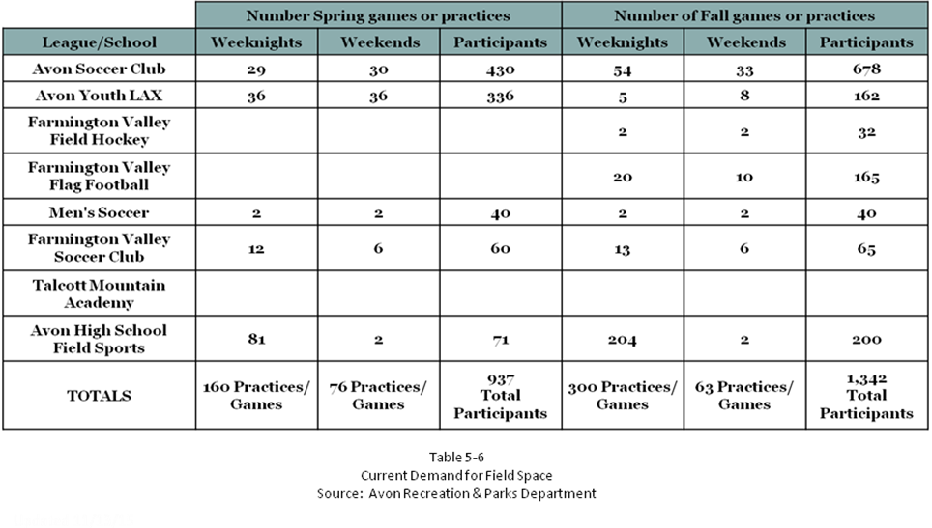
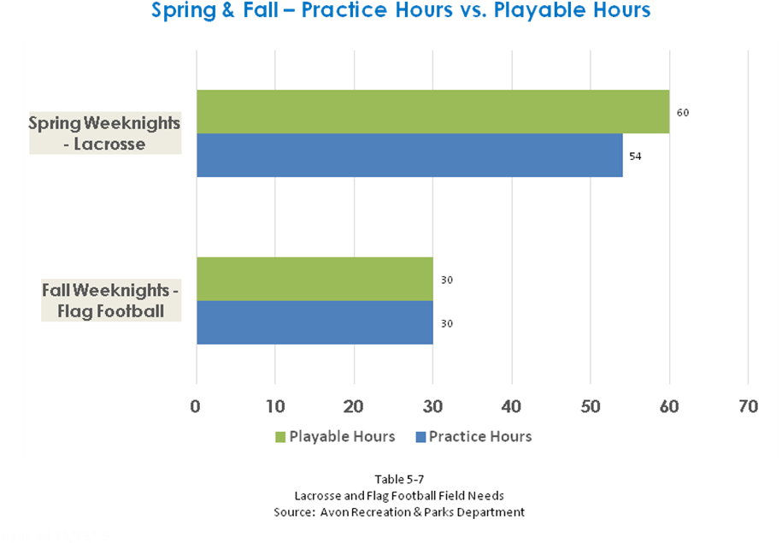

There is a very significant demand for participation in youth, soccer, lacrosse, and flag football. Each of these sports has associated stakeholders advocating for sufficient field space for practices and games. The construction of the Buckingham Recreation Area grass fields and, although not ideal, use of Alsop Meadows for two grass fields has helped accommodate these demands for now; however, additional field space is still required. The lack of lighted fields makes scheduling more challenging.

In 2011 a study of possible new field construction at Fisher Meadows was conducted by Richter and Cegan Landscape Architects and site plan approval was granted by the Planning and Zoning Commission. This plan demonstrates the feasibility of the construction of 7 additional multi-purpose playing fields and a new 200-car parking lot. This appears to be the best option for increasing field space when reviewing Town assets. Exhibits 5-1 and 5-2 show this conceptual layout.
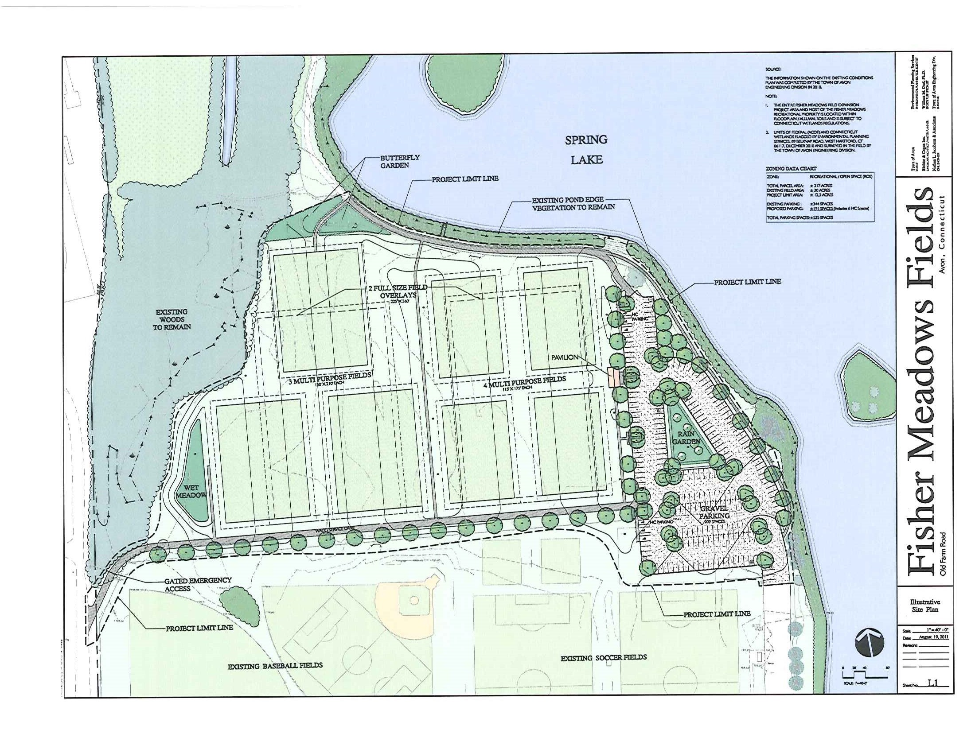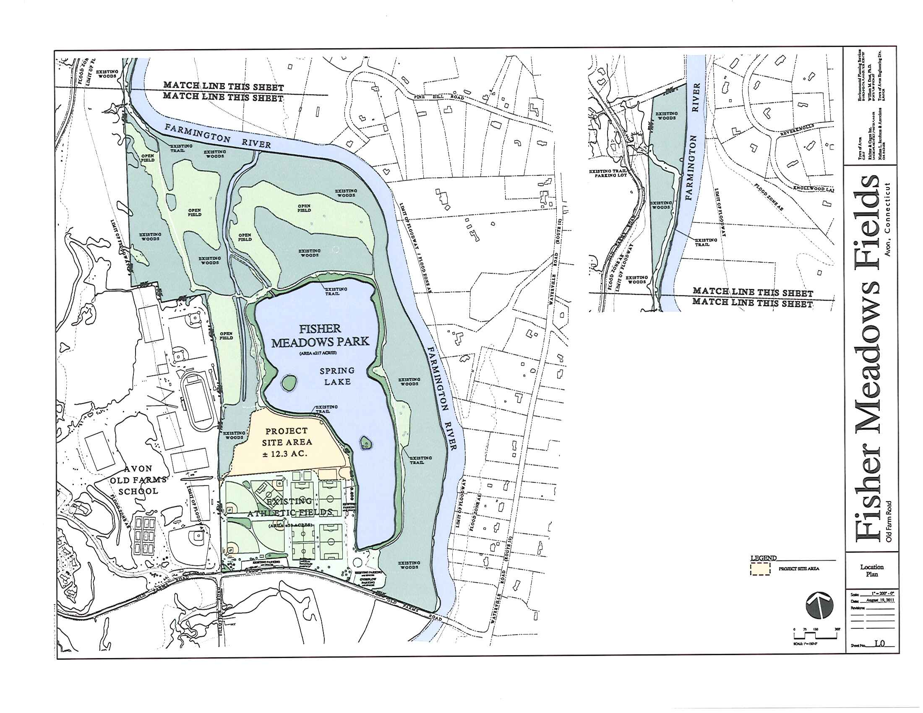
Exhibits 5-1 and 5-2 Potential Layout for Field and Parking Expansion at Fisher Meadows
The Recreation and Parks Commission has also identified the need to construct a field with an all-weather synthetic turf surface to be used for high school athletics as well as certain youth sports programs administered by the Town Recreation and Parks Department. The Avon Town Council is currently reviewing 2 locations and has hired a landscape architect to conduct a feasibility study for each. These are the High School (redevelopment in the area of the current football field) and 99 Thompson Road. At this time, it appears that the most prudent location for the all-weather synthetic turf field is the High School. Should this be the case, the Thompson Road site could be used to construct additional practice fields. This land is currently zoned industrial, as a remnant of the former M.H. Rhodes manufacturing facility. The Commission should consider rezoning this land to ROS (recreation open space) consistent with other Town assets used for this purpose.

The current limited availability of existing indoor recreation facilities also present some programming challenges to meet demands. It is recommended that the Town conduct a study of existing indoor recreational spaces, how to better utilize these spaces, and consider future needs.

Goal and Policies

Goal:
Maintain sufficient open space to preserve community character, provide passive recreational opportunities for residents, achieve numerous environmental benefits associated with open space, develop and maintain adequate recreational facilities to meet increased demand for active recreation.

Policies:
1. Utilize the authority granted to the Commission to accomplish open space preservation when reviewing various applications for site plan, special permit, and subdivision approval.

2. Encourage the use of cluster or open space subdivisions versus traditional large lot subdivisions on remaining larger tracts of land. Open space areas should be meaningful larger contiguous areas.

3. Based on strong support for open space acquisition from the Commission’s survey, the Town should pursue acquisition of some of the targeted high priority parcels as they become available for sale. Seek Federal and State funds to assist in purchase when available. Utilize the fee-in-lieu of open space account to assist in providing matching funds to State and Federal funding.

4. Consider expansion of the Town’s hiking trail network in accordance with recommendations in this chapter.

5. Consider construction of an added section of the Farmington Valley Greenway (aka Rails to Trails) from Sperry Park south to Arch Road. Promote the current route through Avon Park North and South as the “main” trail to support the proposed commercial development in Avon Village Center.

6. Consider an amendment to the Subdivision Regulations governing the dedication of open space to authorize the Commission to accept a conservation easement in lieu of open space dedication or fee-in-lieu where appropriate.

7. Work with various Town Departments, including Parks and Recreation and Public Works, to promote, advocate for, and request adequate funding to maintain and improve what has now become a very significant assemblage of Town open space assets and trail networks.

8. Conduct a study of indoor recreational facilities, as discussed. Pursue expansion of practice fields at Fisher Meadows or 99 Thompson Road to meet demand. Continue to evaluate Avon High School and 99 Thompson Road as locations for the construction of an all-weather synthetic turf field.

/tmp/lo/0000.doc

