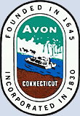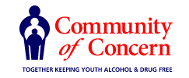

Avon YSAB/ LPC/ COC Meeting Agenda

June 7, 2023
6:30PM- 8:00 PM

Avon Public Library Board Room 2nd Floor

- Welcome and Introductions - Communication from the audience (limited to five minutes)

- YSB Coordinator update of Programs and Local Prevention Council

- Review of Vaping Program AHS with Vicky Adams, Southern Ct State University
- QPR and Youth Mental Health First Aid with Justine Ginsberg (FVHD) and APL
- Mental Health/Self Care Programming partners APL and AYS
- Calm Kits
- Programs for Pride Month, Juneteenth, Interval House Programs for Youth

- Board Members Updates

- Input from Student Leaders regarding topics that concern Youth-Avon High School
- Avon Police Department Update and JRB
- Partners in Prevention / Truancy / School Refusal Behaviors
- First Responder Camp July 17-19th 2023 for teens entering 9th and 10th Grade
- Planning for upcoming programs: Mentoring Programs/Positive Youth Development/Wellness would like to develop a committee to assist comprised of Youth and Adults similar to TAB
- Adjournment

Next meeting: Fall 2023 TBD

