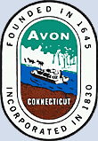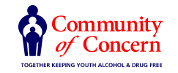

Avon YSAB/ LPC/ COC Meeting Agenda

March 28, 2023
6:30PM- 8:00 PM

Avon Public Library Board Room 2nd Floor

- Welcome and Introductions - Communication from the audience (limited to five minutes)

- YSB Coordinator update of Programs and Local Prevention Council

- Vaping Prevention Program at AHS

- Board Members Updates

- Guest – Emily Cintorino – Director of Community Programs at Interval House

- Input from Student Leaders regarding topics that concern Youth
- Avon Police Department Update and JRB
- Partners in Prevention / Truancy / School Refusal Behaviors
- Compliance Checks for local businesses
- Drug Take Back Day Saturday April 29th
- Adjournment

Next meeting: TBD

