POCD Chapter 9 (DRAFT) Business and Industry September 27, 2016

Avon is very fortunate to have a well-balanced, diverse mix of business and industrial uses. For a Town with a population of about 18,700 and an area of 22.5 square miles, Avon has a substantial amount of retail, office, and industrial development. Avon’s first Plan of Conservation and Development in 1956 and each successive Plan has made provisions for business growth. There are currently 6 business zoning districts and two industrial districts which comprise a total of 1,051 acres or 7.1% of the Town. Table 9-1 presents this information.

ZONE | TOTAL ACRES | % OF TOWN
Commercial Retail (CR) | 170 | 1.1
Commercial Specialized (CS) | 80 | .5
Commercial Park A (CPA) | 56 | .4
Commercial Park B (CPB) | 47 | .3
Neighborhood Business (NB) | 24 | .2
Office Park (OP) | 53 | .4
Avon Village Center (AVC) | 108 | .7
Industrial Park (IP) | 370 | 2.5
Industrial (I) | 143 | 1.0
TOTAL | 1,051 | 7.1
Table 9-1 Land Zoned for Business and Industry

There are approximately 104 acres of remaining vacant land zoned for business and industry. The largest remaining property is a 93-acre site located in Avon Park North, which is discussed later in this Chapter. There will also continue to be opportunities for redevelopment. There have been a number of commercial and industrial properties which were developed during the 1950’s and through the 1980’s which have since been redeveloped (in some instances two or more times). There are also opportunities for the redevelopment of other properties, as market conditions warrant additional private investment. Table 9-2 presents a partial list of commercial properties which have been redeveloped over the past 20 years.

PROJECT NAME | ADDRESS | YEAR REDEVELOPED
Walmart Plaza/Big Y | 255 West Main Street | 1999 , 2002
Nod Brook Mall | 315 West Main Street | 2011
Avon Marketplace | 380 West Main Street | 2009
Goodwill Plaza (former TJ Maxx) | 260 West Main Street | 2014
Bank of America (former Fleet Bank) | 240 West Main | 1997
Plaza 44 | 195 West Main Street | 1998
Sovereign Bank | 205 West Main Street | 2004
Avon Village (formerly known as Old Avon Village) | 1-5 East Main Street | 1984 , 1999
Fairway Shops | 56 East Main | 1995
Riverdale Farms | 124 Simsbury Road | 2005
Hartford Hospital Wellness Center | 100 Simsbury Road | 1999
Hartford Hospital (former Blockbuster Video) | 339 West Main Street | 2011
Table 9-2 Partial Listing of Commercial Properties Redeveloped 1996-2016

The community survey conducted by GreatBlue Research asked residents several questions regarding their opinions on the possible rezoning of additional land for business development. When residents were asked if they would support rezoning of land from residential to business only 35% were in favor. Residents were also asked about the type of new business development they would most prefer (on land currently zoned for business). A majority of residents (65%) favored additional small retail shops, as long as this growth could be done in a manner which retains community character and causes little effect on the movement of traffic. In addition, 66% of participants in the survey indicated support for more business development to help reduce the tax burden on homeowners. Exhibit 9-1 presents these findings

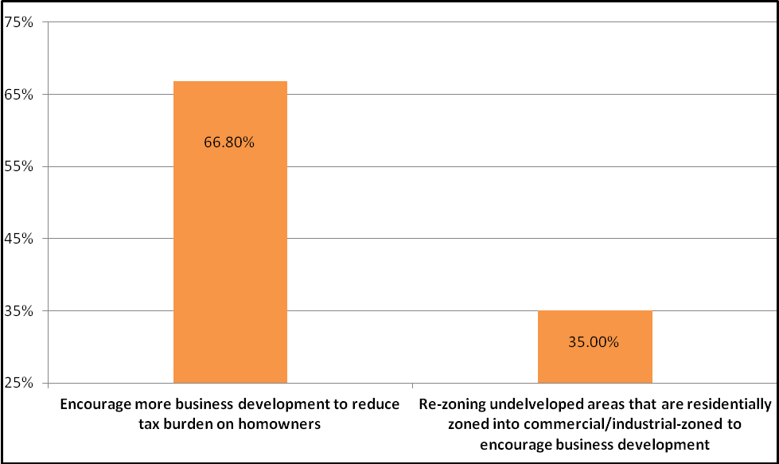 Exhibit 9-1 Residents’ Opinions on Promoting More Business Growth
Source: GreatBlue Research, Survey December 2015

Survey participants who favor additional retail development have a strong preference for small retail shops, in comparison to mid-size or large retail stores. Exhibit 9-2 summarizes these opinions.
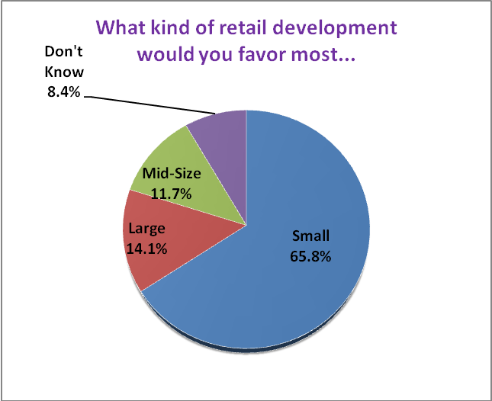
Exhibit 9-2 Type of Retail Development Most Favored by Residents
Source: GreatBlue Research, Survey December 2015

The Commission’s past planning policies to promote an appropriate amount of commercial development and its implementation through planning and zoning regulations has resulted in a large measure of convenience to residents in obtaining needed professional services, such as medical, as well as in meeting retail needs. Sixty-five percent (65%) of survey respondents indicated that they were able to obtain needed professional services within Avon either always or most of the time. Seventy-seven percent (77%) of those participating in the survey indicated that they were able to accomplish needed retail shopping within Avon either always or most of the time.

In Avon the majority of revenue needed to fund services is obtained from the taxation of “real” and personal property. Real property includes the value of land and all things permanently attached, such as buildings, structures, and improvements. Personal property includes tangible items related to a business which is not fixed to a location and can be moved, such as business equipment, machinery, and computers. The total value of these assets Town-wide is known as the Grand List. Commercial properties provide a major contribution to the Grand List. For the year 2015 the grand list was 2.6 billion dollars. Of this, 15% was attributable to taxes paid to the Town from owners of commercial real estate, as well as individual businesses.

Although Connecticut’s system of taxation often results in a competitive environment to attract business and industry, the health of Avon’s local business environment is clearly linked to the health of the regional economy as well. In many ways, the fact that adjoining towns are prospering makes it easier, not more difficult, to attract and retain business in Avon.

Avon businesses employ over 8,000 individuals. The U.S. Census Bureau reports 595 businesses in 2013 with a total annual payroll of $362,306,000. Convenient access to goods and services for Avon residents, a significant number of jobs within the community, and an impressive contribution in Town taxes by Avon businesses have resulted in a sustainable economy. However, like private business, the Commission and its Zoning Regulations must be responsive to changes in the retail, office, and industrial marketplace.

The Commission’s Regulations are designed to promote a safe, functional, attractive, and competitive environment. This Chapter includes a discussion about how the Commission may consider modifying these Regulations to be more responsive to an increasingly challenging environment in the retail, office, and industrial sectors.

There has been a very dramatic increase in the use of the internet for purchasing retail goods over the past 10 years. This has placed added strain on many traditional brick and mortar retailers. Many national retailers have scaled back expansion plans since the last economic downturn in 2006, and, in some instances, have been targeting only what they consider to be A+ locations. Avon has many positive attributes which are attractive to retailers. These include:

- Attractive safe environment (The Commission has worked hard to promote an attractive and functionally safe commercial corridor.)
- High per capita income (including surrounding Towns). The 2014 per capita income of Avon residents is $66,365 or 172% higher than the State average.
- Substantial traffic volumes on Route 44. Average daily traffic volumes range from 19,500 to 28,900 on Route 44 (See Chapter 10).

However, Avon and adjacent towns lack the population density which some retailers are seeking, perhaps, placing the Town outside of the top tier of choices. Modest population and job growth is expected over the next 10-year period in Avon, the surrounding area, and in the State over the next planning period.

Many commercial property owners have made substantial investments in building renovations and site improvements to remain competitive and attractive in this more challenging environment. Two recent examples include substantial site improvements at Avon Marketplace (380 West Main Street) resulting in a more pedestrian-friendly layout (2009) and the division of the former TJ Maxx store (260 West Main Street) into 3 smaller tenant spaces which reflects the current challenging environment to attract larger format retailers (2014). There may also be opportunities to shift from a strict separation of business and residential uses in select locations toward more of a mixed-use environment. Two recent examples include the approval of the Peachtree Village elderly housing development, located in Avon Park South (2008) on land zoned Industrial Park (IP) and the master plan approval of a mixed-use development in Avon Center (2015 - discussed next). The Commission recognizes challenges that commercial property and business owners face, supports innovations and investments such as these, and will continue to work cooperatively with owners in connection with future applications.

In addition, the ability to transmit data over the internet at the fastest speed which technology permits offer a huge competition advantage. The commission encourages investments, both public and private to facilitate business communications.

Avon Village Center
In 2005 the Planning and Zoning Commission prepared a study for Avon Center and adopted this development plan as part of the 2006 Plan of Conservation and Development. This Study is officially adopted as part of this Plan and is included as Appendix B. The Study’s main objectives are to create opportunities for a mixed-use, pedestrian-friendly development in the area of Avon Park North in order to create a more vibrant Town Center. A second study was completed in 2010 by the firm of Milone & MacBroom, which included recommendations for the creation of a new mixed-use zoning district to be known as the Avon Village Center Zone (AVC). Regulations were adopted by the Commission in July 2011. The land owner, Avon Park Properties, prepared a master plan for 93 acres of land located in Avon Park North. In February 2012 the Commission approved a master plan which included the construction of a main street, approximately 600,000 square feet of retail and office space and 300-500 condominium and apartment units. Exhibit 9-3 presents this plan.

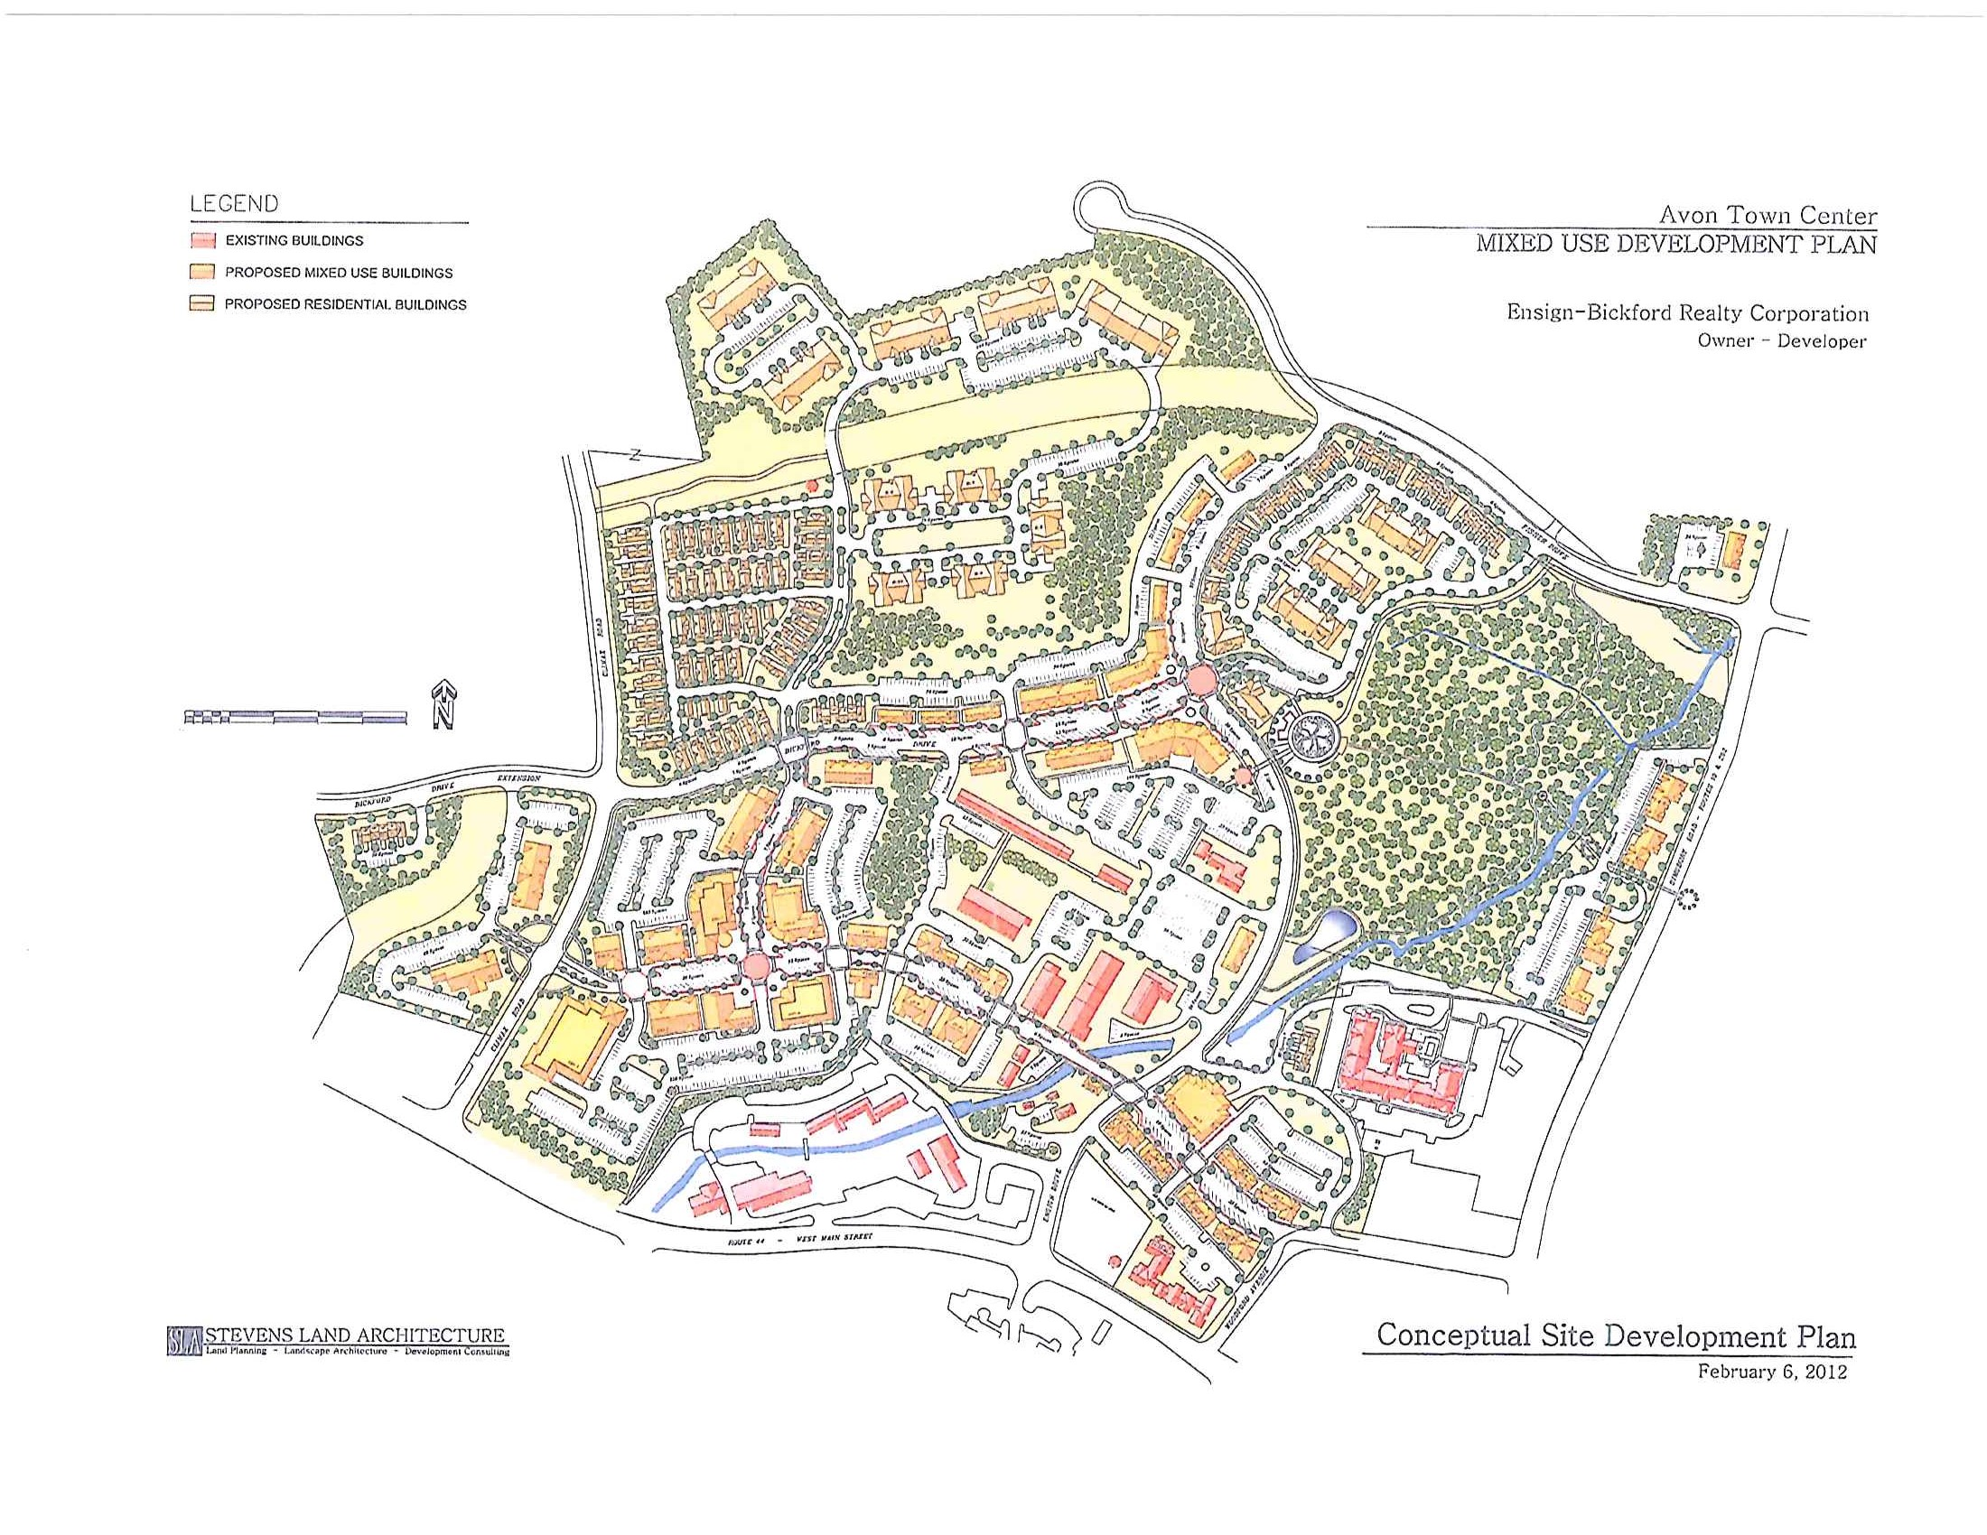
Exhibit 9-3 Approved Master Plan for Avon Village Center, Avon Park Properties
Dated February 6, 2012

There will be opportunities to incorporate sustainable elements to this project through design and the use of various technologies. The following should be considered in the development of this project:
- Use of Low Impact Design Principles (Please see Chapter 4 for a detailed discussion).
- Use of green technologies to generate power including solar, wind, and geothermal.
- Use of building construction technologies and materials beyond minimum requirements established by the Connecticut State Building Code to achieve maximum energy efficiencies.
- Construction of a micro-grid providing for the power needs of the development.
- Use of high-efficiency lighting for both interior and exterior lighting.
- Construction of an electric recharging station to serve customers, employees, and residents.

This master plan was structured such that the property could be developed by several individual development companies or a single master developer.

In 2015 the entire 93-acre site went under contract with the Carpionato Group; a revised master plan was submitted and approved by the Commission on November 17, 2015. Subsequently, the Carpionato Group has purchased approximately 60 of the 93 acres.

This Plan also includes a mix of retail shops, restaurants, offices, cultural amenities, apartments, and condominiums with a somewhat greater emphasis on the commercial retail component. The approved Plan, at the developer’s initiative, also calls for the reconstruction of several existing roadways in addition to the construction of a new “main street”. Other substantial capital improvements are proposed including intersection improvements at Climax Road and Route 44; Ensign Drive and Route 44; Fisher Drive and Route 10; upgrades to public sewers and public water; possible relocation of a 36-inch water line owned by the MDC; and construction of two public gathering spaces. Exhibit 9-4 presents this approved plan.

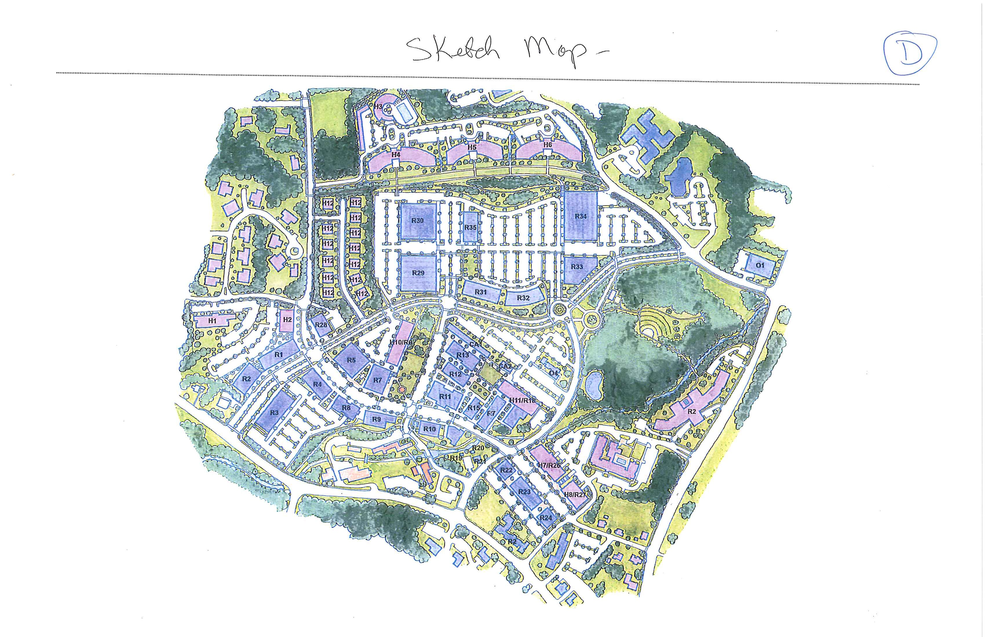
Exhibit 9-4 Approved Master Plan for Avon Village Center, Carpionato Group
Dated November 17, 2015

This 93-acre site was used as a successful manufacturing facility from the turn of the century until 1969. In 1972 it was “reinvented” with the support of the Commission into a suburban office business park. Regulations were developed and a zone known as Industrial Park (IP) was created. Although there are many successful businesses within the Park today stemming from this effort, the Commission believes its latest efforts to rezone this area to a new mixed-use zone is responsive to current market demands and will result in an attractive project with safe pedestrian and bicycle access to restaurants, shopping and services.

The Commission expects to receive detailed site plans for portions of this project over the next several months. This project represents the most significant opportunity for a new commercial development in Avon at this time. This project will place added emphasis on Avon Center, reinforce its special character, and likely encourage other residential and commercial projects outside the current boundaries of the Avon Village Center Zone. The Commission may wish to consider expanding the boundaries of the AVC zone as this project progresses and interest expands to nearby areas. Please also see Chapter 11 future land use recommendations for added discussion.

Multifamily Housing
Chapter 7 identifies several parcels of land that merit further investigation regarding the possible construction of multifamily housing. These include properties currently zoned Industrial Park (IP), Commercial Retail (CR), and Commercial Specialized (CS). Please refer to Chapter 7, Housing, for a more detailed discussion.

Parking Requirements
The Institute of Transportation Engineers (ITE) is one group that collects data relating to parking needs for hundreds of commercial, industrial, and residential projects. The Commission also has gained much knowledge of parking demand in Avon through the numerous applications it has reviewed.

The current required parking ratios for retail, restaurant, and office uses (based on a rate per 1,000 square feet of gross floor area) may be high, in certain instances. The Commission may elect to study this further and possibly reduce required rates. Avon’s zoning regulations, require that every site developed for business or industrial use retain a minimum of 50% of the site as green space. A reduction in required parking could permit building expansion opportunities while still maintaining compliance with lot coverage requirements. This would, in some instances, permit additional development opportunities on already developed parcels. The Commission may also wish to set standards which relate to the location of parking relative to public entrances. This would ensure a majority of parking within a defined radius of each commercial use.

Design Review Standards
Over the past 50 years, the Commission has emphasized quality design in buildings, site layout, and landscaping, resulting in some very attractive projects in all commercial and industrial zones. The Commission may wish to consider the adoption of written guidelines which will make clear the Commission’s design expectations to all applicants. Presently, such standards exist only for the Avon Village Center Zone (AVC). Current Zoning Regulations authorize the Commission to grant a density bonus of 10% (50% -60% lot coverage) with a demonstration of design excellence. The adoption of written guidelines will establish the Commission’s design expectations and help define “excellence” in an instance where a bonus is sought.

Consolidated Parcel Agreements and Access Management
Increased traffic volumes on Route 44 has made turning movements associated with the entering and exiting of driveways serving commercial properties more challenging. Significant improvements to Route 44 over the past several decades have been made to help address this situation, including additional signalization, the widening of the roadway at key intersections and the addition of dedicated turn lanes. To address this situation, it continues to be a goal of the Commission to reduce the number of driveways at unsignalized intersections.

The consolidation or elimination of curb cuts or new driveway cuts is referred to as access management. Avon has been in the forefront of access management for many years. One means to accomplish this is through the implementation of the Commission’s Consolidated Parcel Agreement Regulations. Under these Regulations, private property owners may jointly submit a site plan for redevelopment and earn certain zoning advantages relating to parking, setbacks, and lot coverage as a result. The consolidation of several sites into a single, unified layout has provided opportunities for improved site circulation and driveway safety. The ability to accomplish such a unified plan can be challenging, as two or more individual property owners must first enter into a private agreement which they ultimately conclude is to their mutual benefit. The Commission may wish to study these Regulations and provide even further incentives relating to permitted lot coverage and parking to make it more likely that they will be utilized.

Table 9-3 lists those commercial properties which have entered into a consolidated parcel agreement and have been approved by the Commission.

Westridge Shops (former Tri-Town Plaza) | 320 West Main Street
Farmington Bank | 310 West Main Street
DP3 LLC (former Westledge Realty) | 300 West Main Street | Vol 222 Page 276
CH Associates | 200 West Main | Vol 209 Page 376
Joseph and Mary Martino | 210 West Main | Vol 209 Page 376
OAVX Associates | 1 East Main Street | Vol 376 Page 233
Shops at Applewoods LLC | 51 East Main Street | Vol 376 Page 233
Riverdale Farms LLC | 124 Simsbury Road
Silvio Brighenti Family LLC | 100 Simsbury Road
Albemarle Avon LLC | 336 West Main Street | Vol 372 Page 77
Waldman Avon LLC | 380 West Main Street | Vol 372 Page 77
GDK LLC | 332 West Main Street | Vol 372 Page 77
Table 9-3 Properties with Approved Consolidated Parcel Agreements

Route 44 Corridor Study
A 1998 study conducted by the Connecticut Department of Transportation and endorsed by the Commission contained several recommendations which are still relevant today. A complete copy of this Study may be viewed in the office of Planning and Community Development. Recommendations include the construction of a 24-foot wide raised center landscape median from the Simsbury Town line east to Climax Road, directing all left-hand turning movements to signalized intersections. This would significantly add to public safety and is discussed more in Chapter 10. It is recommended that the Town work with the Avon Chamber of Commerce and all business owners with frontage on this section of the roadway to further discuss this plan. The Town may also wish to consider promoting the creation of a Business Improvement District (BID). Such an organization would be in a position to collect modest fees from members to be used to promote the district, as well as landscape maintenance along the corridor.

Goal and Policies

Goal
Provide areas for commercial and industrial services and regulations which promote a safe, varied, convenient, and attractive environment to serve the needs of the residents of Avon.

Policies
1. Carefully refine and apply the requirements and design standards of the Avon Village Center Zone to accomplish the construction of a quality mixed-use, pedestrian and bicycle-friendly project that will enhance Avon Center.

2. Consider expanding the boundaries of the Avon Village Center Zone to other nearby properties to promote similar development following the completion of a substantial portion of the 2015 approved master plan for Avon Park North.

3. Consider conducting a study of current parking requirements to determine if some standards could be reduced while still satisfying parking demand, creating additional redevelopment opportunities.

4. Consider adopting design review standards which will help define the Commission’s expectations regarding building design, site layout, and landscaping for commercial zones other than AVC.

5. Study existing consolidated parcel agreement regulations. Consider added incentives such as lot coverage bonuses and parking reductions to encourage the joint redevelopment of commercial properties aimed at promoting improved site circulation, public safety, and private investment.

6. Study the advantages of implementing recommendations in the 1998 DOT Route 44 Corridor Study which relate to construction of a landscape center median between the Simsbury Town line and Climax Road, directing all left-hand turns to existing signalized intersections. Discuss and meet with the business community to:

1. To implement the 1998 Route 44 Corridor Study;

2. Discuss alternative methods of paying for the median;

3. Discuss ways to maintain median strip if it is constructed, and;

4. Discuss the advantages of establishing a Business Improvement District (BID) to support landscape maintenance and the business promotion within the district.

/tmp/lo/0000.doc

