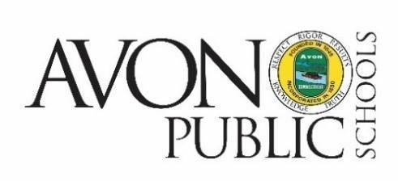

NOTICE OF BOE
CURRICULUM AND PROFESSIONAL PRACTICES (C&PP) COMMITTEE MEETING CANCELLATION

The C&PP Committee meeting of the Avon Board of Education scheduled for Tuesday, February 14, 2023 has been canceled.

Avon Public Schools
34 SIMSBURY ROAD
AVON, CONNECTICUT 06001
TEL: (860) 404-4700

