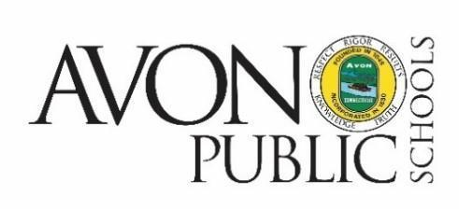

NOTICE OF BOE
POLICY COMMITTEE MEETING CANCELLATION

The Policy Committee meeting of the Avon Board of Education scheduled for Tuesday, March 7, 2023 has been canceled.

Avon Public Schools
34 SIMSBURY ROAD
AVON, CONNECTICUT 06001
TEL: (860) 404-4700

