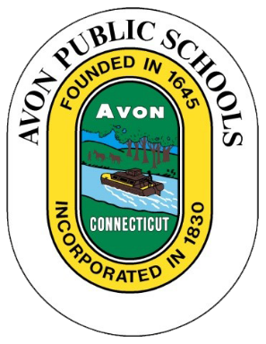

Community Input Session
Superintendent's Proposed Budget
for the
2017-2018 School Year
The Avon Public School central administration is seeking the public's input to help build the Superintendent's proposed budget for the upcoming 2017-2018 school year. The Community Input Session will be offered on Thursday, October 6th at 6:00 pm. The meeting will be held in the Community Room of Avon High School. All Avon residents are welcome to attend and speak.

WHAT: Community Input Session—Superintendent's Proposed Budget for the 2017-2018 School Year
WHEN: Thursday, October 6th at 6:00 pm
WHERE: Avon High School - Community Room

